AWS no SQl table (DynamoDB)

* Login to AWS console and under databases click the DynamoDB

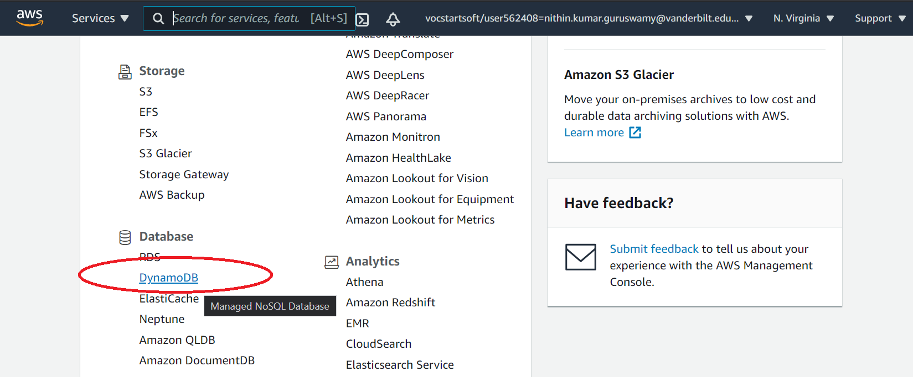

* Click on the create table

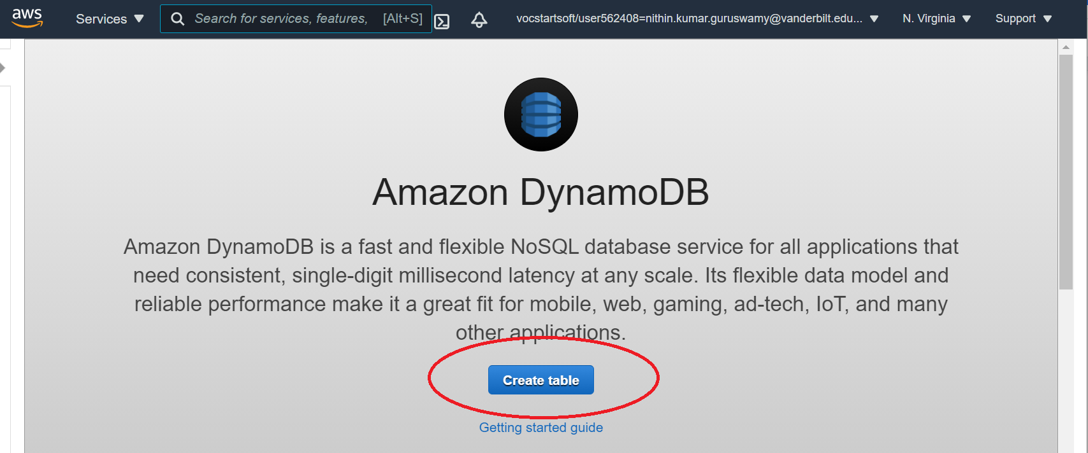

* DynamoDB table is created with name- Music and Primary Key and Sorted Keys

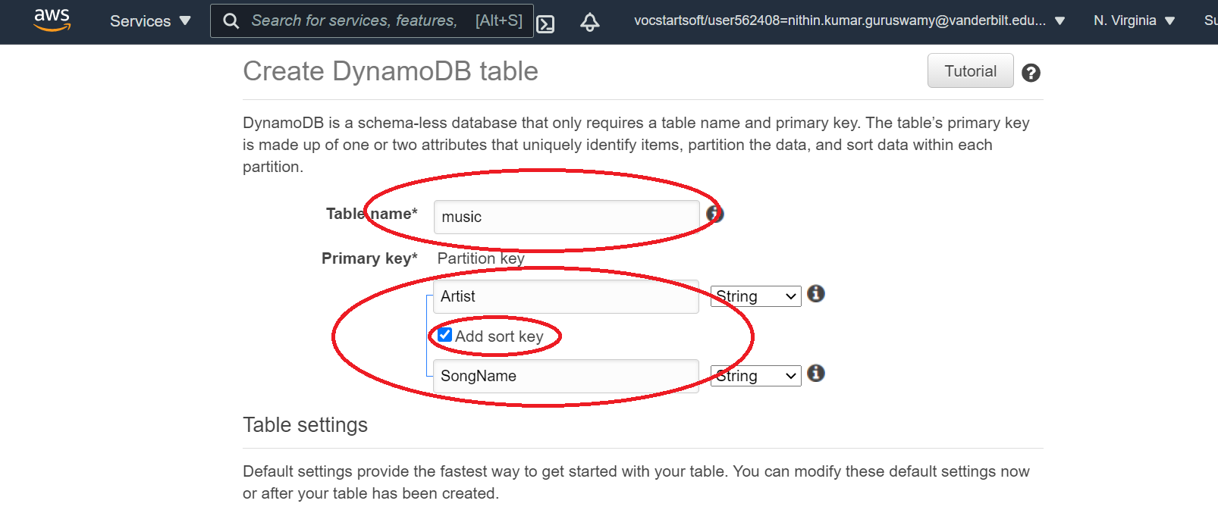

* Use the default settings for table and click create the table

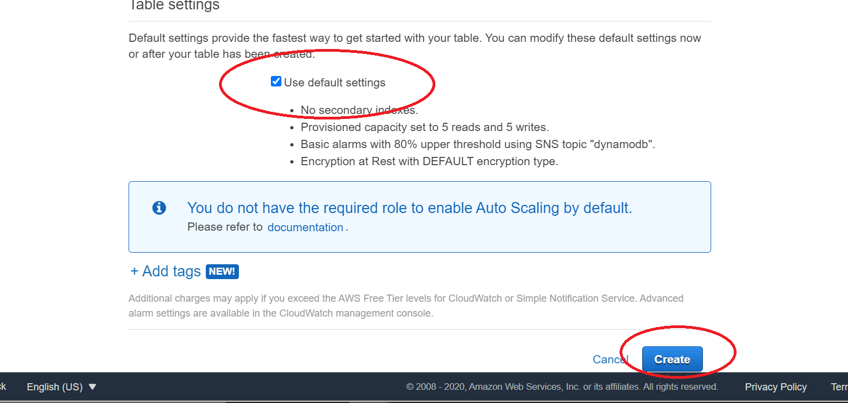

* After creating the Table add items(Key value pairs) to it

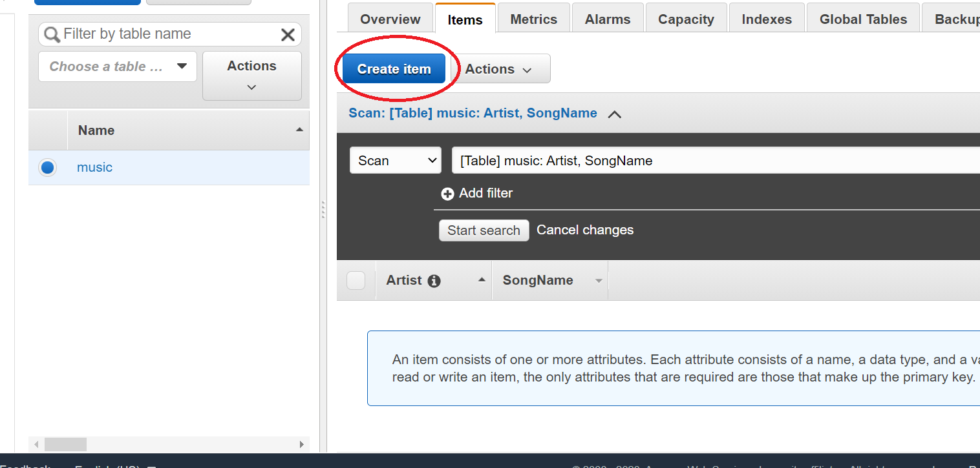

* Add values for the keys

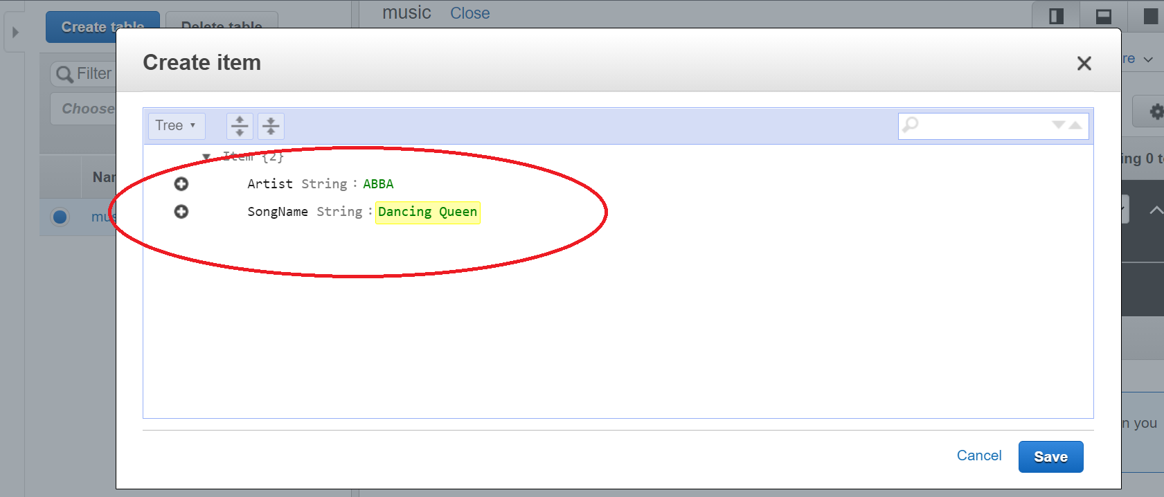

Query for the i

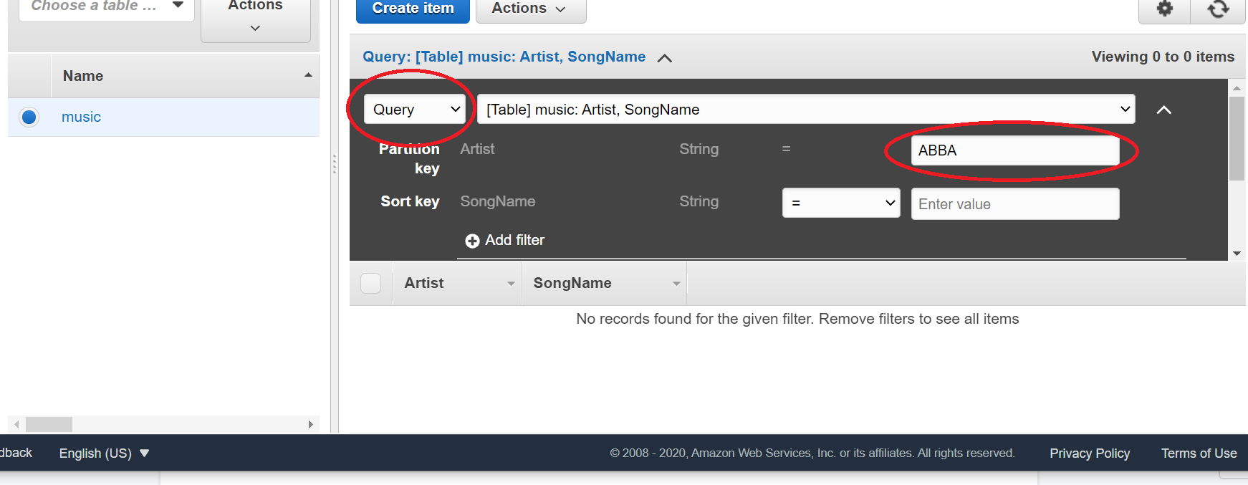

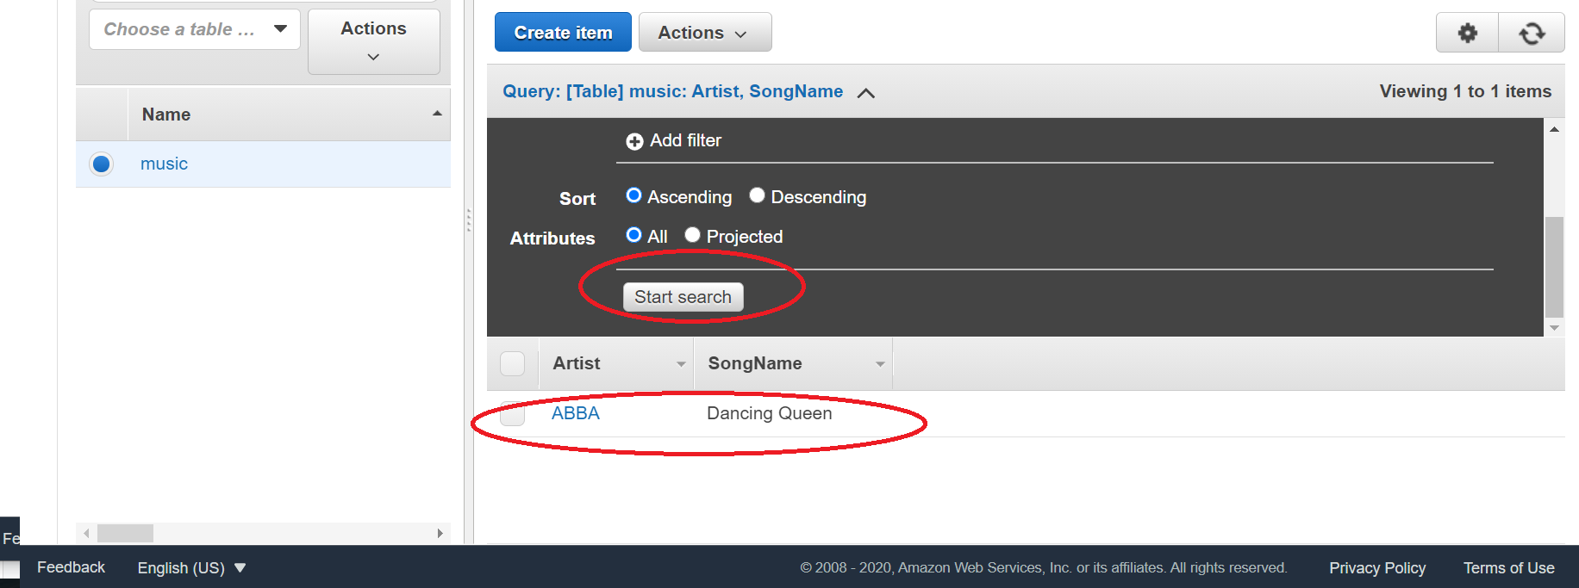

* Deleting the item (Key value pair)

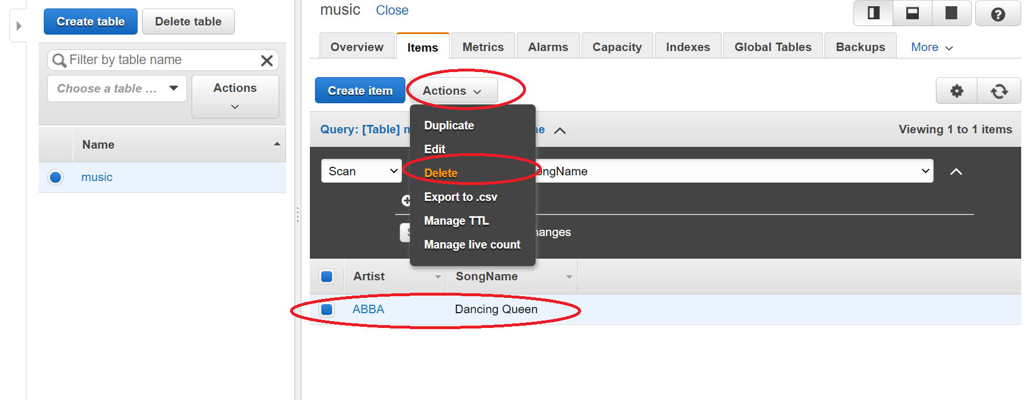

* Delete the table (Delete unused table to prevent being charged)

